App.js from RAVENOUS

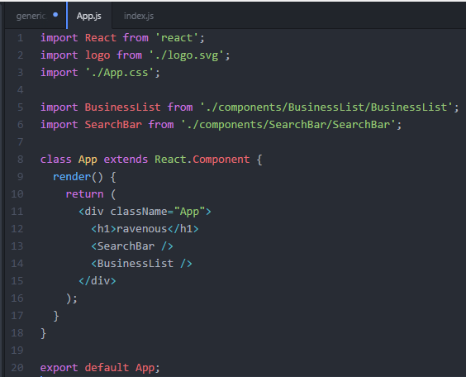

Index.js from RAVENOUS

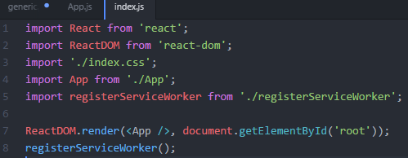

**I think yes**… Do we only work on App.js and App.css in the Components/App directory?? Not the src directory?

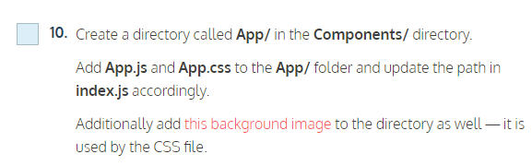

STEP 27 renderAction method ???